Notification icon

Step 1:
Add the notification count and the button.
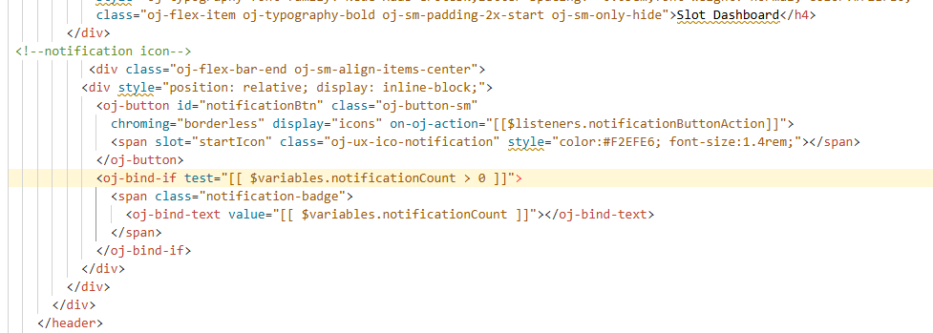
<div class="oj-flex-bar-end oj-sm-align-items-center">
<div style="position: relative; display: inline-block;">
<oj-button id="notificationBtn" class="oj-button-sm"
chroming="borderless" display="icons" on-oj-action="[[$listeners.notificationButtonAction]]">
<span slot="startIcon" class="oj-ux-ico-notification" style="color:#F2EFE6; font-size:1.4rem;"></span>
</oj-button>
<oj-bind-if test="[[ $variables.notificationCount > 0 ]]">
<span class="notification-badge">
<oj-bind-text value="[[ $variables.notificationCount ]]"></oj-bind-text>
</span>
</oj-bind-if>
</div>
</div>
Step 2:
add the popup or dialog box
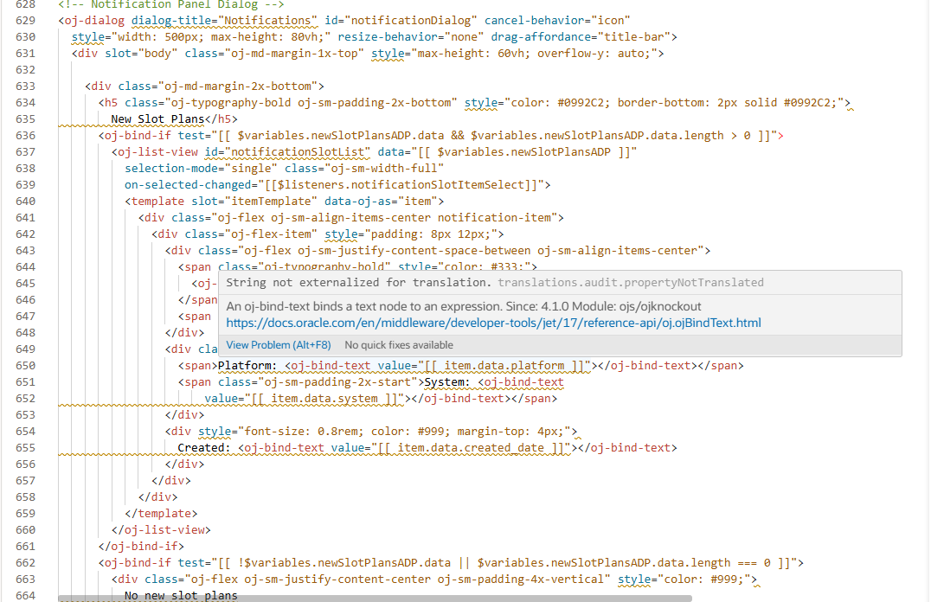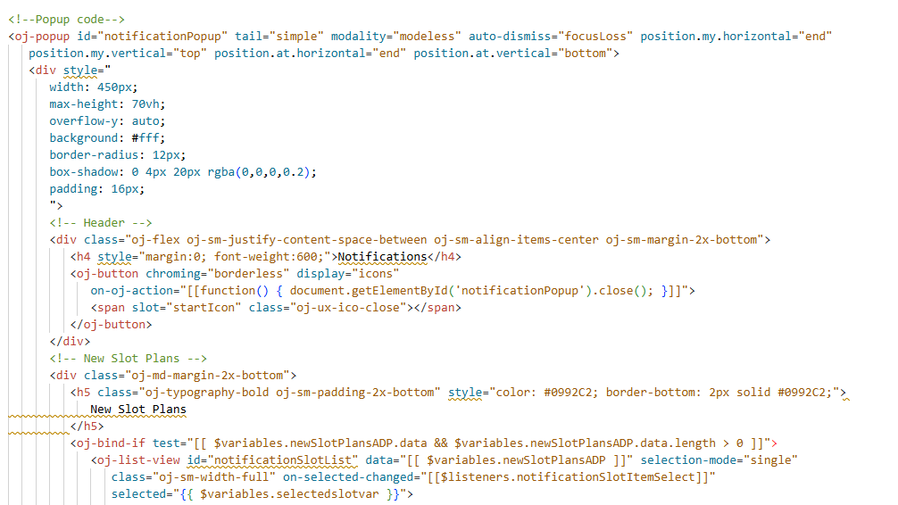
Step 3: add variables and then add type
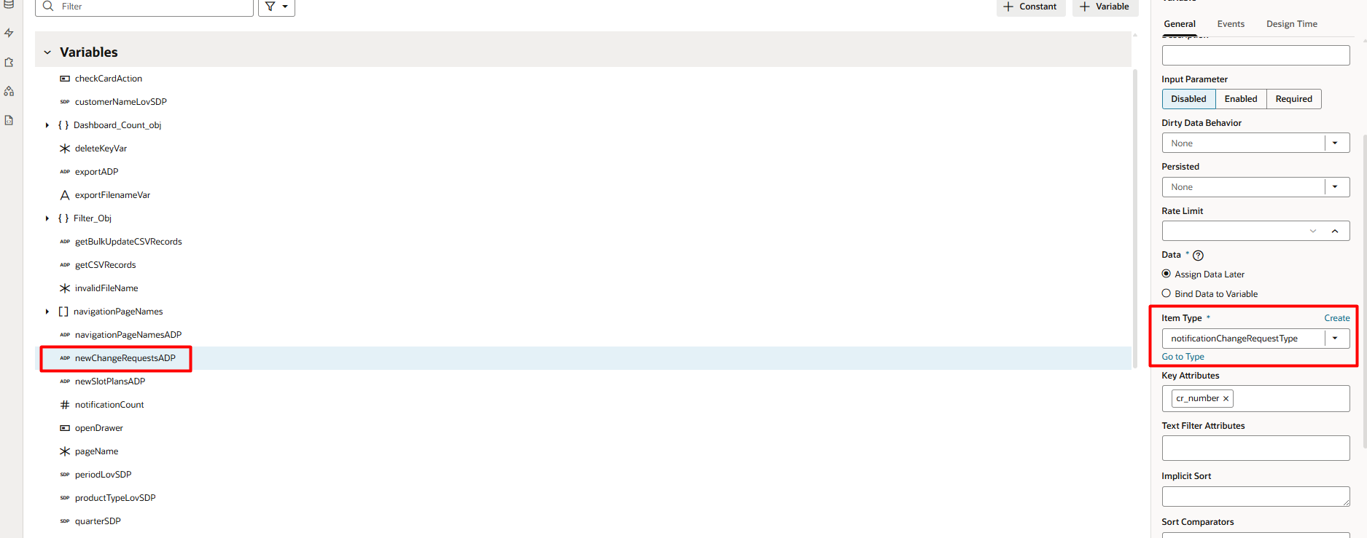
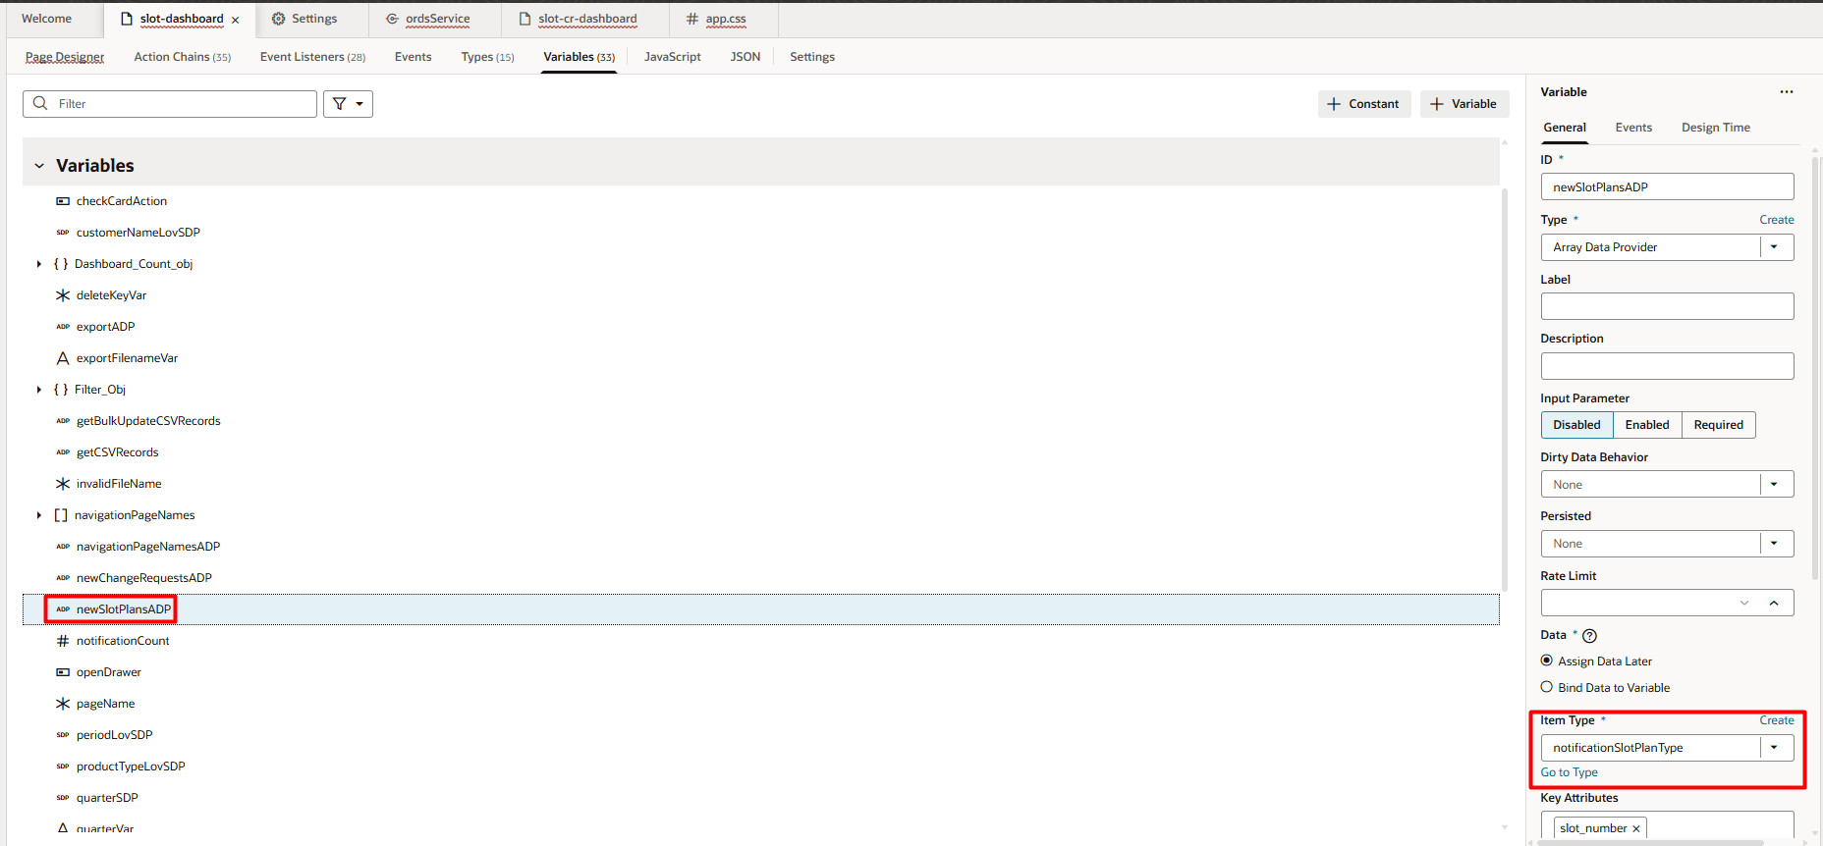
Type :
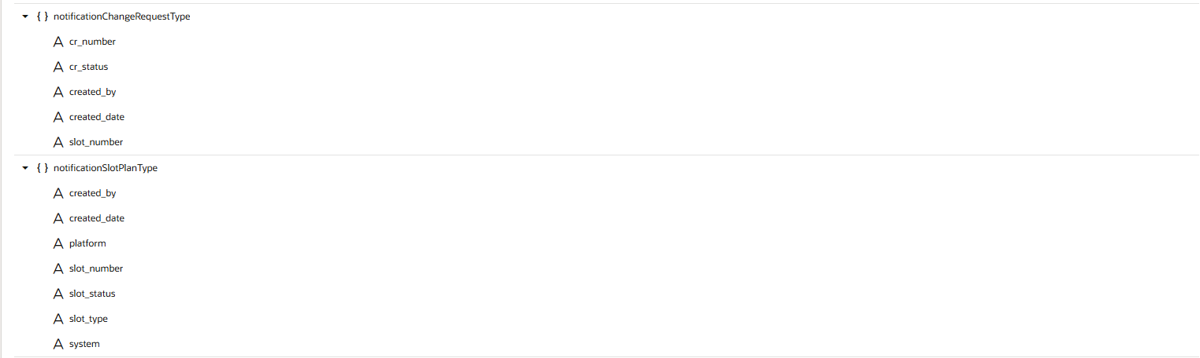
Action chain:
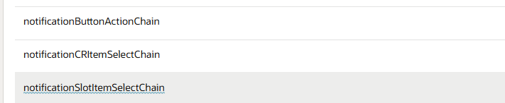
markAllNotificationsReadChain:

define([
'vb/action/actionChain',
'vb/action/actions',
'vb/action/actionUtils',
], (
ActionChain,
Actions,
ActionUtils
) => {
'use strict';

class markAllNotificationsReadChain extends ActionChain {

/**
* @param {Object} context
* @param {Object} params
* @param {object} params.event
* @param {any} params.originalEvent
*/
async run(context, { event, originalEvent }) {
const { $page, $flow, $application, $constants, $variables } = context;

const response = await Actions.callRest(context, {
endpoint: 'ordsService/postMarkNotificationsRead',
body: {
user: $application.user.email,
},
});

if (response.ok) {
$variables.newSlotPlansADP.data = [];
$variables.newChangeRequestsADP.data = [];
$variables.notificationCount = 0;

await Actions.fireNotificationEvent(context, {
summary: 'All notifications marked as read',
type: 'confirmation',
});
} else {
await Actions.fireNotificationEvent(context, {
summary: 'Error marking notifications as read',
type: 'error',
});
}

const notificationDialogClose = await Actions.callComponentMethod(context, {
selector: '#notificationDialog',
method: 'close',
});
}
}

return markAllNotificationsReadChain;
});

notificationButtonActionChain:

define([
'vb/action/actionChain',
'vb/action/actions',
'vb/action/actionUtils',
], (
ActionChain,
Actions,
ActionUtils
) => {
'use strict';

class notificationButtonActionChain extends ActionChain {

/**
* @param {Object} context
* @param {Object} params
* @param {object} params.event
* @param {any} params.value
*/
async run(context, { event, value }) {
const { $page, $flow, $application, $constants, $variables, $functions } = context;

const progressMsgOpen = await Actions.callComponentMethod(context, {
selector: '#progressMsg',
method: 'open',
});

const slotResponse = await Actions.callRest(context, {
endpoint: 'ordsService/getGetGetNewSlotPlans',
});

if (slotResponse.ok) {
$variables.newSlotPlansADP.data = slotResponse.body.items || [];
} else {
$variables.newSlotPlansADP.data = [];
}

const crResponse = await Actions.callRest(context, {
endpoint: 'ordsService/getGetGetNewChangeRequests',
});

if (crResponse.ok) {
$variables.newChangeRequestsADP.data = crResponse.body.items || [];
} else {
$variables.newChangeRequestsADP.data = [];
}

$variables.notificationCount = $functions.getNotificationCount(
$variables.newSlotPlansADP.data,
$variables.newChangeRequestsADP.data
);

const progressMsgClose = await Actions.callComponentMethod(context, {
selector: '#progressMsg',
method: 'close',
});

// const notificationDialogOpen = await Actions.callComponentMethod(context, {
// selector: '#notificationDialog',
// method: 'open',
// });
document.getElementById('notificationPopup').open(event.target);
}
}

return notificationButtonActionChain;
});

notificationCRItemSelectChain
define([
'vb/action/actionChain',
'vb/action/actions',
'vb/action/actionUtils',
], (
ActionChain,
Actions,
ActionUtils
) => {
'use strict';

class notificationCRItemSelectChain extends ActionChain {

/**
* @param {Object} context
* @param {Object} params
* @param {object} params.event
* @param {any} params.value
*/
async run(context, { event, value }) {
const { $page, $flow, $application, $constants, $variables } = context;

if (value && value.keys && value.keys.keys.size > 0) {
const selectedCRNumber = value.keys.keys.values().next().value;

const notificationDialogClose = await Actions.callComponentMethod(context, {
selector: '#notificationDialog',
method: 'close',
});

await Actions.navigateToPage(context, {
page: 'change-request-page',
params: {
crNumber: selectedCRNumber,
action: 'View',
},
});
}
}
}

return notificationCRItemSelectChain;
});
notificationSlotItemSelectChain
define([
'vb/action/actionChain',
'vb/action/actions',
'vb/action/actionUtils',
], (
ActionChain,
Actions,
ActionUtils
) => {
'use strict';

class notificationSlotItemSelectChain extends ActionChain {

/**
* @param {Object} context
* @param {Object} params
* @param {object} params.event
* @param {any} params.value
*/
async run(context, { event, value }) {
const { $page, $flow, $application, $constants, $variables } = context;

if (value && value.keys && value.keys.keys.size > 0) {
// const selectedSlotNumber = value.keys.values().next().value;
const selectedkey = value.keys.keys.values().next().value;

// ---- TODO: Add your code here ---- //
console.log("selected slot number"+selectedkey);

const notificationDialogClose = await Actions.callComponentMethod(context, {
selector: '#notificationDialog',
method: 'close',
});
}
}
}

return notificationSlotItemSelectChain;
});
Javascript :
PageModule.prototype.getNotificationCount = function (slotPlans, changeRequests) {
const slotCount = Array.isArray(slotPlans) ? slotPlans.length : 0;
const crCount = Array.isArray(changeRequests) ? changeRequests.length : 0;
return slotCount + crCount;
};

3. add css
.notification-badge {
position: absolute;
top: 2px;
right: 2px;
background-color: #E74C3C;
color: #FFFFFF;
border-radius: 50%;
min-width: 18px;
height: 18px;
font-size: 0.7rem;
font-weight: bold;
display: flex;
align-items: center;
justify-content: center;
padding: 0 4px;
line-height: 1;
pointer-events: none;
}
.notification-item {
border-bottom: 1px solid #eee;
transition: background-color 0.2s ease;
}
.notification-item:hover {
background-color: #f5f9fc;
}
.notification-item:last-child {
border-bottom: none;
}
#notificationDialog .oj-dialog-body {
padding: 12px 16px;
}
/* AI Generated Code by Deloitte + Cursor (END) */

